EXPERIMENT 23-QR ENABLED AUTOMATIC BUS TICKET BOOKING SYSTEM
AIM:
To create a QR-enabled automatic bus ticket booking system that generates a QR code for the passenger's ticket

STEP 1 — Install required modules
Run:
pip install mysql-connector-python qrcode pillow
The manual lists Tkinter, qrcode, PIL, random, mysql-connector.

STEP 2 — Create project folder
Create:
BusTicketBooking
Inside it create:
bus_ticket.py

STEP 3 — Create MySQL database
Open MySQL Workbench and run:
CREATE DATABASE IF NOT EXISTS busdb;
USE busdb;

STEP 4 — Create passenger table
CREATE TABLE IF NOT EXISTS passenger2 (
id INT AUTO_INCREMENT PRIMARY KEY,
first_name VARCHAR(50),
last_name VARCHAR(50),
password VARCHAR(50)
);

STEP 5 — Insert test passenger
INSERT INTO passenger2
(first_name, last_name, password)
VALUES
('Chakri', 'K', '1234');

PYTHON CODE:
import tkinter as tk
from tkinter import messagebox
import mysql.connector
import qrcode
import random

# ---------- MYSQL CONNECTION ----------
conn = mysql.connector.connect(
host="localhost",
user="root",
password="YOUR_MYSQL_PASSWORD",
database="busdb"
)

cursor = conn.cursor()

# ---------- FUNCTIONS ----------

def book_ticket():
name = name_entry.get()
age = age_entry.get()
source = source_var.get()
destination = destination_var.get()
payment = payment_var.get()

if name == "" or age == "" or source == "Select" or destination == "Select":
messagebox.showerror("Error", "Enter all details")
return

ticket_no = "BUS" + str(random.randint(1000, 9999))

data = (
name,
int(age),
source,
destination,
payment
)

cursor.execute("""
INSERT INTO bus_ticket
(name, age, source, destination, payment)
VALUES (%s, %s, %s, %s, %s)
""", data)

conn.commit()

# QR data
qr_data = f"""
BUS TICKET
Ticket No: {ticket_no}
Name: {name}
Age: {age}
From: {source}
To: {destination}
Payment: {payment}
"""

qr = qrcode.make(qr_data)
qr.save("bus_ticket_qr.png")

messagebox.showinfo(
"Success",
f"Ticket Booked Successfully!\n\n"
f"Ticket No: {ticket_no}\n"
f"QR Code: bus_ticket_qr.png"
)

# ---------- MAIN WINDOW ----------

root = tk.Tk()
root.title("QR Enabled Bus Ticket Booking")
root.geometry("450x550")

tk.Label(
root,
text="BUS TICKET BOOKING",
font=("Arial", 20, "bold")
).pack(pady=20)

tk.Label(root, text="Name").pack()
name_entry = tk.Entry(root)
name_entry.pack()

tk.Label(root, text="Age").pack()
age_entry = tk.Entry(root)
age_entry.pack()

tk.Label(root, text="Source").pack(pady=(15, 0))

source_var = tk.StringVar(value="Select")
tk.OptionMenu(
root,
source_var,
"Tirupathi",
"Chennai",
"Bangalore"
).pack()

tk.Label(root, text="Destination").pack(pady=(15, 0))

destination_var = tk.StringVar(value="Select")
tk.OptionMenu(
root,
destination_var,
"Hyderabad",
"Bangalore",
"Chennai"
).pack()

tk.Label(root, text="Payment").pack(pady=(15, 0))

payment_var = tk.StringVar(value="UPI")
tk.OptionMenu(
root,
payment_var,
"UPI",
"Cash"
).pack()

tk.Button(
root,
text="BOOK TICKET",
command=book_ticket,
width=20
).pack(pady=30)

root.mainloop()

conn.close()

Create the table:
USE busdb;

CREATE TABLE IF NOT EXISTS bus_ticket (
id INT AUTO_INCREMENT PRIMARY KEY,
name VARCHAR(50),
age INT,
source VARCHAR(50),
destination VARCHAR(50),
payment VARCHAR(20)
);

Run Python:
python bus_ticket.py

A Bus Ticket Booking window should open.
Enter:
Name: Chakri
Age: 20
Source: Tirupathi
Destination: Chennai
Payment: UPI
Click:
BOOK TICKET

IMAGES:

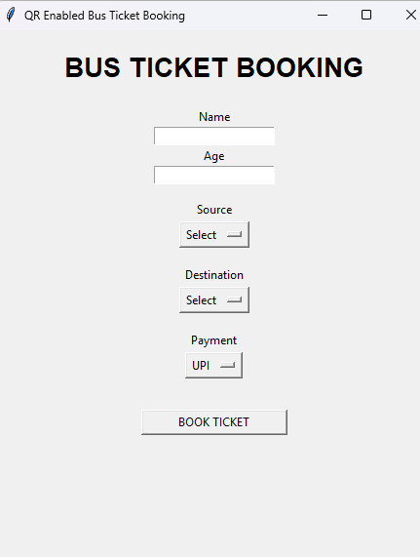
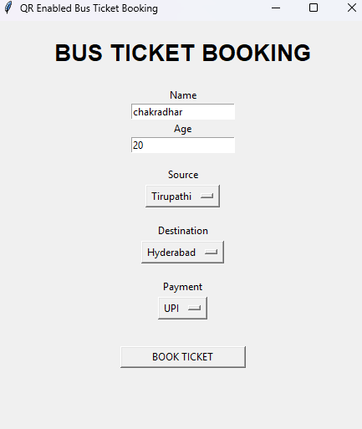

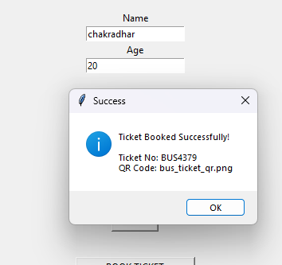
THE QR IS GENERATED IN FOLDER :


OUTPUT OF QR:


RESULT
Thus the QR-enabled automatic bus ticket booking system was successfully implemented using Python and MySQL, and the QR ticket was generated successfully.

